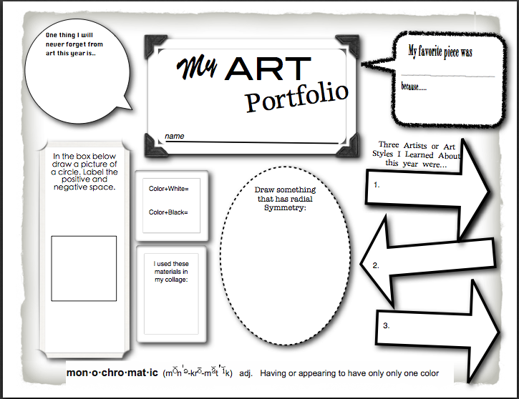

Definition:

Vocab Word:

What skill from art class will you use in the future?

5th Grade Reflection

What was your best piece this year?