Activity (Video game): Minecraft

My Thoughts:
I tried to play this game, but I couldn’t get the free trial to download on my computer, so I read up on its gameplay online, and watched some youtube videos. This one was particularly helpful, hilarious, and inappropriate: http://www.youtube.com/watch?v=fI65t9eN9cM
The graphics are very simple, but the entire world is interactive. The basic idea is that you “mine” resources in the world you are put into (wood, metal, even animal parts) and build shelters to protect you from creatures that come out at night. Most of what the gameplay consists of is randomly exploring the terrain and interacting with the materials in different ways. I actually think the game looks very entertaining, and I like the creative problem solving involved.

Simon’s Perspective:
I think this game appeals to Simon because it allows him a form of escape from his real every day life to create new worlds. The game isn’t particularly violent, and it’s actually very creative. It requires you to use your resources in unexpected ways, and most of this has to be discovered as you play the game. I can see Simon getting lost in the game for hours. It has no definitive end, or natural pauses. Some games have chapters, like books, where natural breaks occur which give the player opportunities to stop playing and take a break or go to bed. This game has none of that. The gameplay is continuous. There would have to be an outside drive, like a parent telling him to stop, to force him to stop playing the game. Without that, he could easily play for hours at a time and not notice how long he has been playing.

Student’s perspective:
I have several students who play this online, and those who are really into it are very willing to share. I even have students who “play” minecraft at recess. Not many students play it regularly, but those who are interested it in get very involved in creating their worlds. I do have a couple of students in particular that are almost obsessive about this game, which is why I chose it. It’s all they talk about and write about. I think there is a place for video games in kids’ lives, but I do feel like some students spend far too much time in front of screens. This game at least involves some creativity and problem solving, but I don’t like thinking that this is the only interest of any of my students.
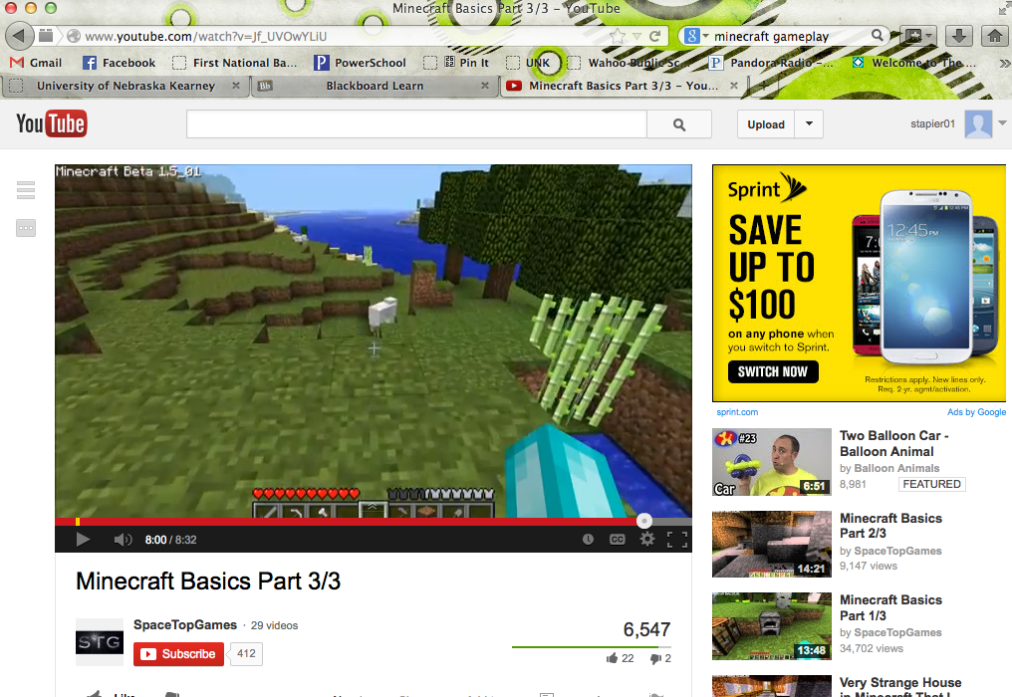

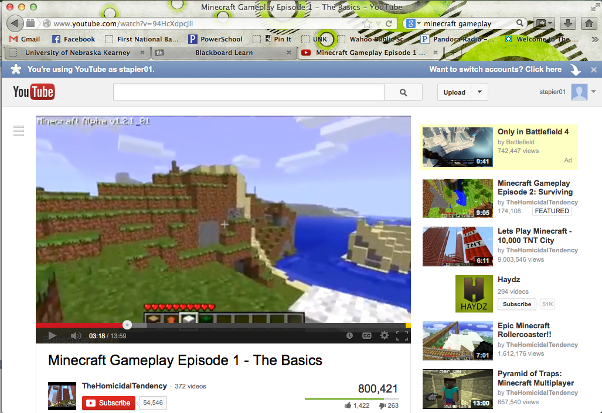
Minecraft randomly generates worlds for you to explore based on different biomes. There are jungles, swamps, tundras, deserts, and meadows. Each biome offers different resources to the user.

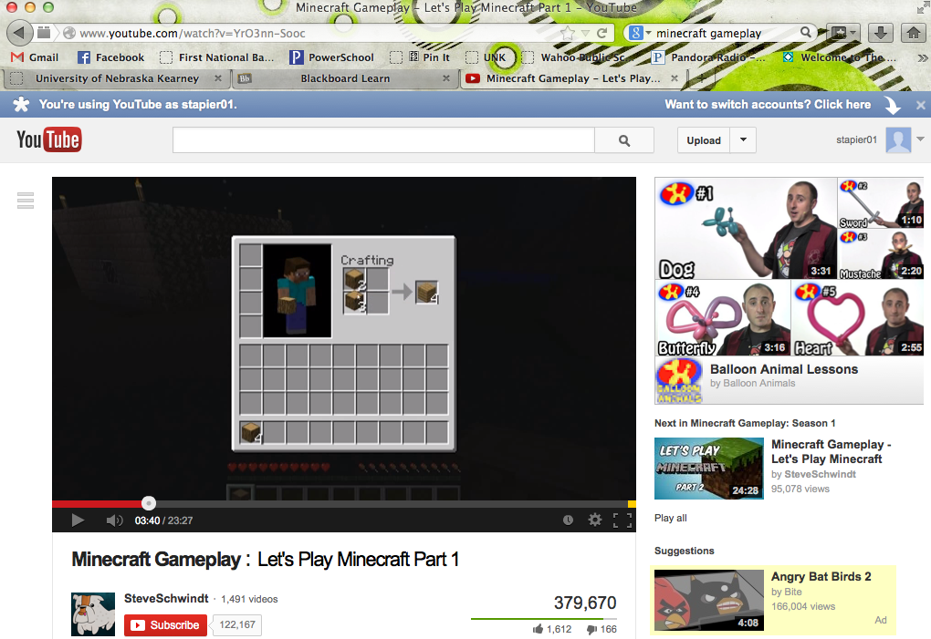
After “mining” or collecting resources, you craft items out of your raw supplies. You use wood to build workbench, which allows you to build more complicated items. You can mine iron to create stronger tools, mine animal furs for clothing, etc.

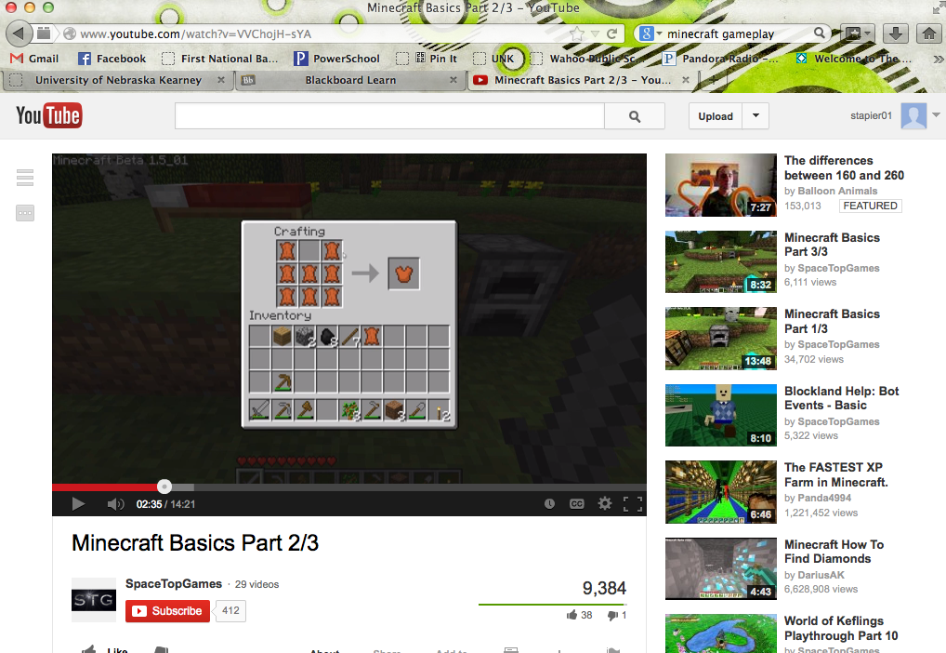
The more varied your resources, the more combinations you can create to make new things. Here, the user is creating a vest out of animal hide.

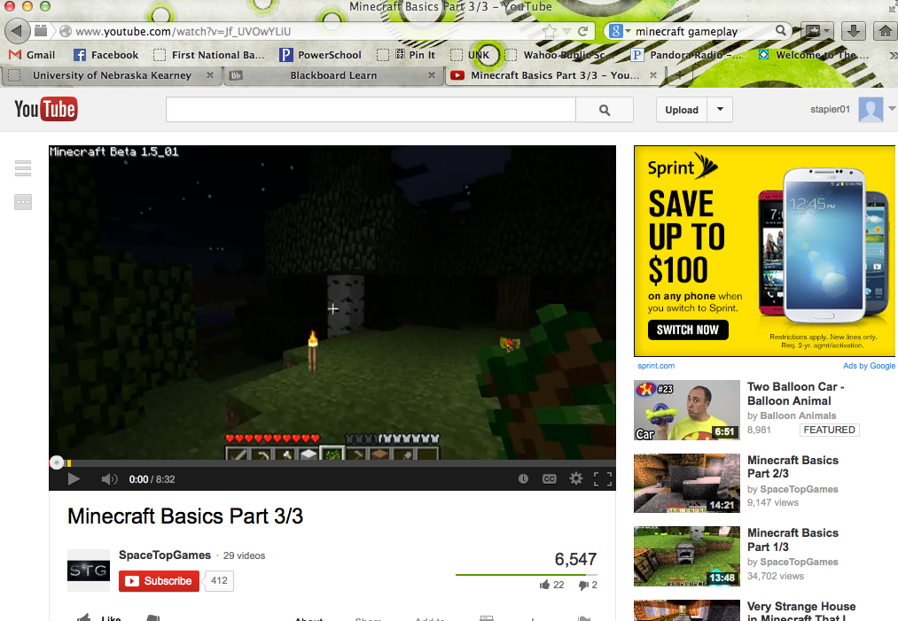
There really is no overall goal of the game other than to interact with the world around you, but one objective is to build a shelter. At night, lots of creatures come out and can kill you. This person used flint and wood to create a fire around his shelter.

